# **Deep Neural Networks**

## **Data and Tasks**

What kind of data and tasks have DNNs been used for?

1. One common example is digit classification using the MNIST dataset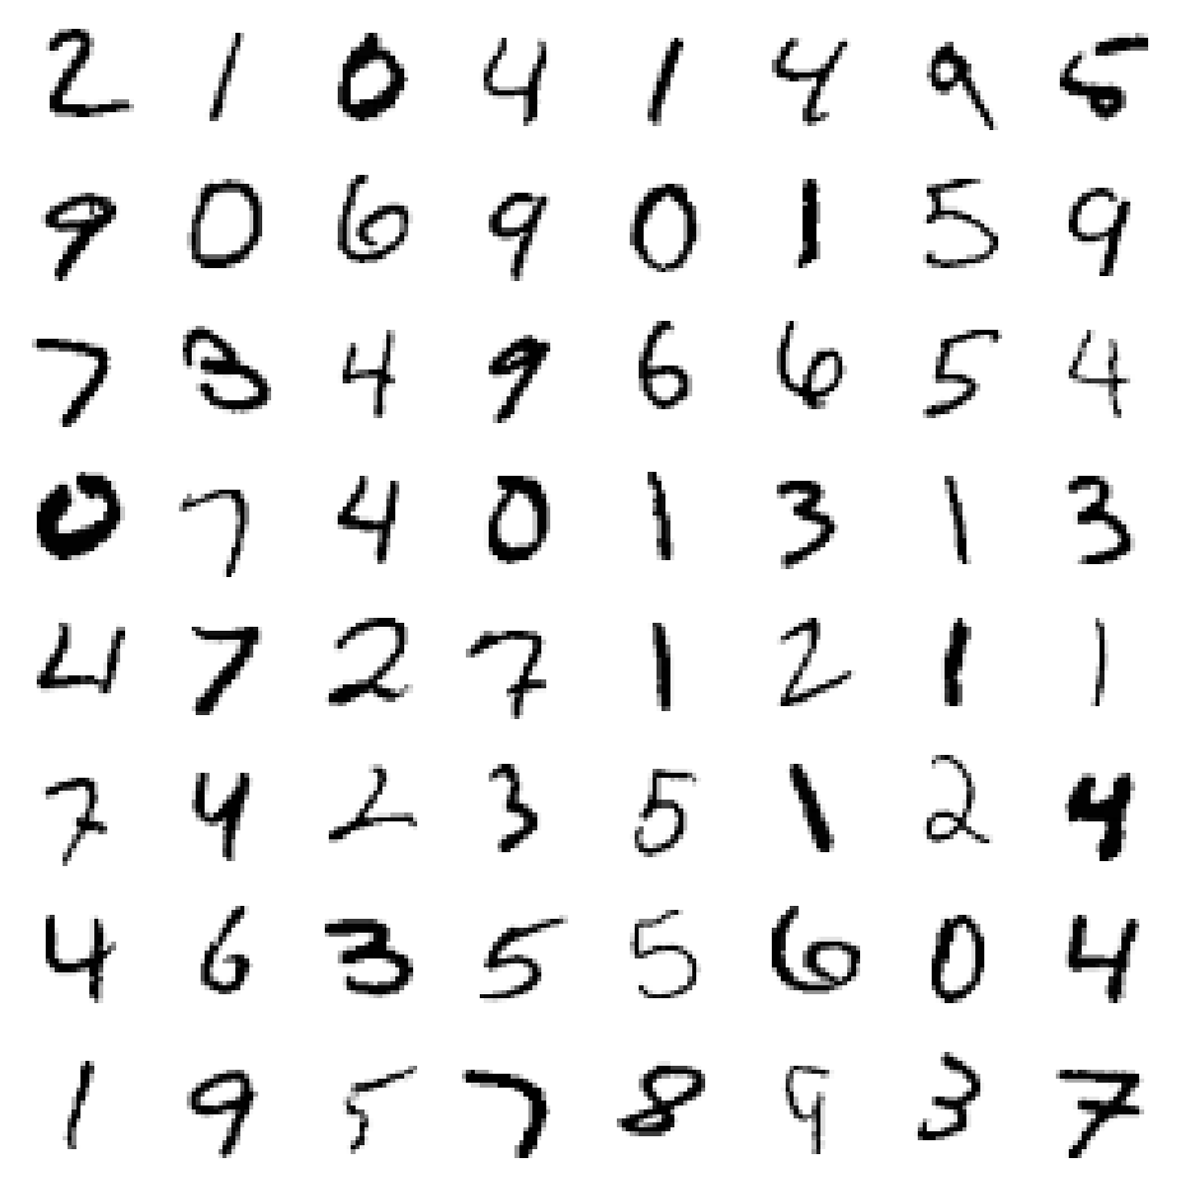
   1. MNIST images are vectorized using the pixel values of each cell
   2. Matrix having pixel values will be of size 28x28 (as MNIST images are of the size 28x28)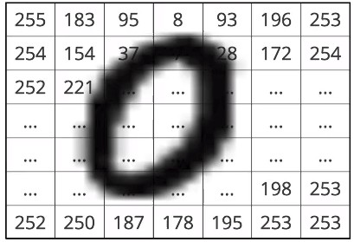
   3. Each pixel can range from 0 to 255. Standardise pixel values by dividing with 255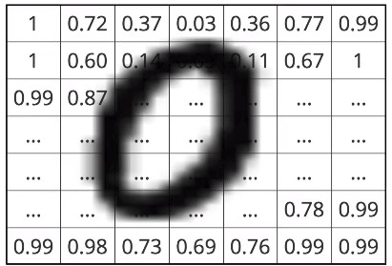
   4. Now, flatten the matrix to convert into a vector of 784 (28x28)
2. Convert all images to vectors of order ℝ784
3. Let’s look at the data along with the labels (Multi-Class Classification)

|  |  |  |  |
| --- | --- | --- | --- |
| **28x28 images** | **Vectorized form** | **Class Label** | **Class Labels - One Hot Representation** |
|  | [1.00, 0.72, … 0.99] | 0 | [1,0,0,0,0,0,0,0,0,0] |
|  | [1.00, 0.85, … 1.00] | 1 | [0,1,0,0,0,0,0,0,0,0] |
|  | [1.00, 0.76, … 1.00] | 2 | [0,0,1,0,0,0,0,0,0,0] |
|  | [0.99, 0.82, … 1.00] | 3 | [0,0,0,1,0,0,0,0,0,0] |
|  | [0.73, 0.81, … 0.67] | 4 | [0,0,0,0,1,0,0,0,0,0] |
|  | [1.00, 1.00, … 0.99] | 5 | [0,0,0,0,0,1,0,0,0,0] |
|  | [0.84, 0.72, … 0.99] | 6 | [0,0,0,0,0,0,1,0,0,0] |
|  | [0.33, 0.52, … 1.00] | 7 | [0,0,0,0,0,0,0,1,0,0] |
|  | [0.85, 0.72, … 0.99] | 8 | [0,0,0,0,0,0,0,0,1,0] |
|  | [0.84, 0.92, … 0.99] | 9 | [0,0,0,0,0,0,0,0,0,1] |

1. Another example would be the Indian Liver Patient classification problem. There are only two possible outcomes, hence it is a Binary-Class classification task
2. An example for regression would be Housing Price Prediction, where instead of predicting a discrete output, the prediction is a real-number or continuous value (decimals, fractions etc)